

**Team #1:** Team Cascade

**NRC:** 5119

**Names:**

* López Almeida Andrés Isaías
* Malte Villarreal Dennis Marcelo
* Medina Armijos Martin Andrés
* Paez Zapata Diego Alexander

**Problem**

It is necessary to create a web page that allows the management of content (mostly images, audio and video) related to the fauna of the Choco Andino reserve area located in the northwestern area of ​​Pichincha, this content management must be carried out by an administrator and visitors can only browse and observe the data collected.

By expecting a large amount of data to be collected we hope to make the website as minimalistic and simple as possible.

**Overview**

Today, having a website for any institution is essential, one of these reasons is the ease with which any type of data can be stored and managed without worrying about losing it and not having any physical backup. That is why the idea of ​​a repository that not only allows us to save this information but also to visualize it in an optimal way, either with the incorporation of a search option that allows us to obtain all the related information or simply allows visitors to discover new things.

**Background**

Access to free information is very important for the dissemination of knowledge, either to compare data that is believed to be incorrect or that is incomplete, as well as to make contributions to the knowledge given, for this reason, information repositories are very popular as a means of disseminating information.

For the construction of repositories (in this case of images and videos), three paths must be taken into account that determine their behavior in addition to the conceptualization, intentions and strategies.

In the first path is the institutional sphere, whose participants are the Universidad de Las Fuerzas Armadas "ESPE" and Mashpi Lodge, one as an entity to which we developers belong and another the institution to which our client belongs, I don't know You can talk about intentions or strategies since both institutions do not participate in the elaboration of this project other than not denying its realization.

In the second path there are the participants, who in This case would be our client who provides us with the data from his organization (with previously granted permission) and we the developers, this as a conceptualization, in the part of the intentions there is the creation of the repository, the client's intentions are to obtain a repository operational taking into account the limitations of the project (which were previously explained) and the intention of us developers are the pertinent ones from the academic field at the end of this route there are the strategies, which as a team have the use of the SCRUM methodology that allows development along with the layout in addition to obtaining the data given by our client.

And finally, in the last path is the synthesis of these three points which will be carried out with a pertinent survey of requirements in addition to direct communication with the client to update him on news or changes that he believes pertinent and are acceptable to implement.

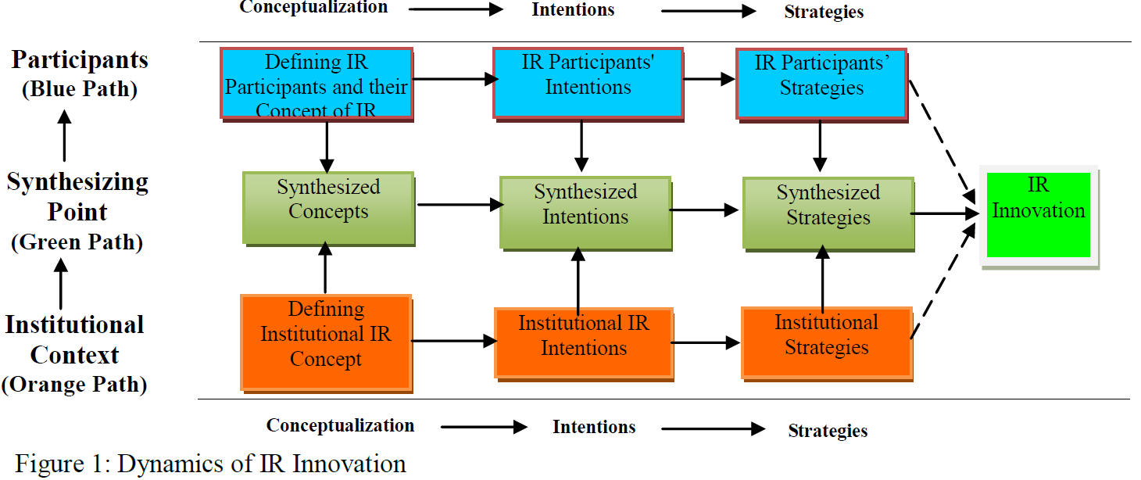

Then there is the point of how the repository interacts with the different academic sections, such as: the author or person who made the photo or video which will have limitations in the first instance, the research around it, libraries, academic discipline, conferences and advertising which these last two are ruled out and how all these factors are appropriate with the search options.

|  | Author | Researches | Libraries | Academic disciplines | Conferences | Comercial publisher |
| --- | --- | --- | --- | --- | --- | --- |
| Visibility |  |  |  |  |  |  |
| Reliable communication |  |  |  |  |  |  |
| Dissemination of the theory |  |  |  |  |  |  |
| Popularity |  |  |  |  |  |  |

Yellow is for possible, green is yes and red is not expected to implement.

This, taking into account the limitations of the project and the client's request, can be synthesized in a simple repository that will provide disclosure information together with a catalog of images and videos assigned to the corresponding type of fauna.